# ****LMS Page Load Issue after Login & Resolution Report (26-3-2025 to 1-4-2025)****

## ****1. Overview****

This report outlines the analysis and corrective measures taken by the LMS vendor development team to resolve the **LMS unavailability and long loading times after login**. The assumption was that high MySQL & PHP CPU utilization (100%) led to performance degradation. The issue was reported on 26th Mar 2025.

**2. Key Issues Identified** Based on the DRCS Development Team’s findings, the delay could be caused by one or more of the following factors:

### ****2.1 High MySQL & PHP CPU Usage (100%)****

* The **server CPU was fully occupied by MySQL & PHP**, affecting system performance.
* Large queries and inefficient indexing caused high resource consumption.

### ****2.2 Slow LMS Login & Page Load Times****

* Significant **delays during login** due to high server load.
* Debugging revealed **some frequent database queries** impacting authentication.

### ****2.3 Large Log Table Impacting Performance****

* **mdl_logstore_standard_log** table had **grown too large**, slowing down query execution.

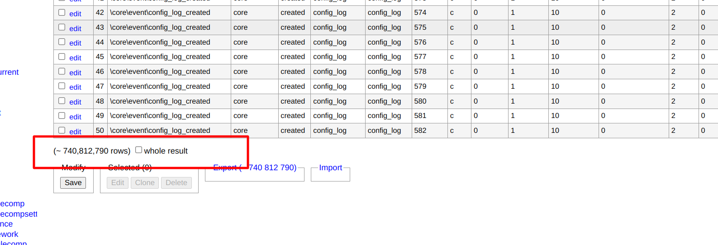

### ****2.4 Background Tasks & Cron Job Overload****

* Stuck or overloaded **cron jobs** consuming excessive server resources.
* 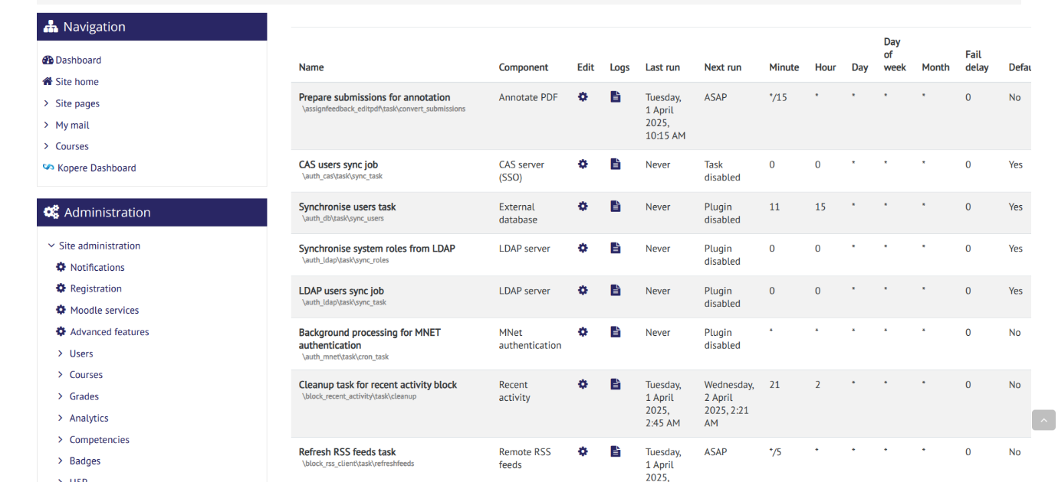

### ****2.5 External Authentication & API Delays****

* **OAuth2 (Gmail Login) delays** due to potential misconfigurations or slow authentication response.

### ****2.6 SSL/Reverse Proxy Delays****

* Possible **SSL/TLS overhead** or misconfigurations causing slow HTTPS requests.

## ****3. Steps Taken for Issue Resolution****

### ****3.1 Server Debugging & Optimization****

* **Checked and debugged login issues** on the server side, including Moodle query optimizations.
* **Checked the process log and services**, which were taking time, like httpd, MySQL, and Apache.
* **Analyzed and reduced MySQL & PHP CPU usage** by identifying inefficient queries and optimizing database performance.

### ****3.2 New Instance Setup & Configuration****

* Upgraded the server configurations: From **4 vCPU to 8 vCPU** and **16GB RAM to 32GB RAM**
* Deployed a **new instance** with the correct **database URL and server domain configuration**:  
   [**http://35.200.159.197**](http://35.200.159.197)
* This is set up to debug and find the possible reasons/processes leading to the slow loading of LMS portal

### ****3.3 Database Optimization****

* **It is suggested that old log entries from mdl_logstore_standard_log be archived** to retain logs only for the past six months.

### ****3.4 Caching & Performance Tuning****

* **Implemented caching mechanism** Redis(cached storage) to reduce database load.

### ****3.5 Background Task & Cron Job Optimization****

* Reviewed and optimized **cron job execution** to prevent excessive resource usage.
* Disabled the Cron jobs to stabilize performance

### ****3.6 Authentication & API Optimization****

* **Checked OAuth2 authentication configuration** in Gmail settings to ensure no unnecessary delays.

### ****3.7 Security & Load Testing****

* **Reviewed server logs** to detect anomalies and potential security risks.
* **Conducted load testing** to assess server performance under peak usage.
* **Increased the session** timeout from **7,400** to **14,400** seconds. This may have contributed to a longer login duration, preventing session expiration

## ****4. Next Steps & Recommendations****

* **Continuous Monitoring** – Monitor MySQL & PHP CPU usage, server logs, and background tasks. Observe it for 1-2 days (so till 3-4-2025) to ensure everything functions smoothly.
* **Log Management** – Keep the log archival for the past six months for optimal performance.
* **Scaling Options** – Consider server upgrades if usage spikes persist.
* **Regular Load Testing** – Ensure the system can handle peak traffic efficiently.

## ****5. Conclusion****

The LMS performance issues were primarily due to **high MySQL & PHP CPU usage and large log tables**. The team has optimized the **caching and cron jobs** to enhance system performance. Ongoing monitoring and load testing will ensure sustained LMS availability and responsiveness.

**Status: LMS Performance Optimized & Issue Resolved on 1st April 2025**